EECE 5698
LAB 7

Q1. Calculate the average hamming distances between the two responses of the same challenge. You can plot a histogram for the 100 hamming distances. Are these responses unique? Why or why
not?

Average hamming distance between the two responses of the same challenge is 6.
Below is the histogram of the 100 hamming distances.
The responses are unique to the each other as the challenge is different for the PUFs as there are no response with hamming distance as 0.
The reason for the getting unique response is the timing difference as each PUF will select different path to reach the flip flop and so we are unique response for each challenge.
From the histogram we can say that it shows normal distribution and therefore the inter chip variation is said to 50% on average which we can see in the average hamming distance which is close to 6 which according to definition should have been close to 8 as we are having 16 bits.

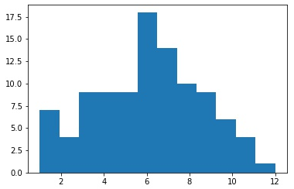

Q2. Each of your PUF will generate 50 responses to the same challenge. You can pick the first response as a reference point, and compute the hamming distance (HD) between it and other 49 responses. Similarly you can plot the 49 HDs in a histogram for each of the PUF. Is your PUF reliable? Why or why not. Do the two PUFs have the same reliability? Why or why not?

For the response for the same challenge I was getting Hamming distance as 0 for all the 16 bits.
This tell us that out PUF had 100 percent reliability, with constant environment temperature as we are not varying any external variables. As we are not changing any external variable we are getting same response for all the challenges. This also tell us that inter chip variability is 0%.

